**Spotlight Game Template**

Modulette ID:

Game #

Game title: Spotlight

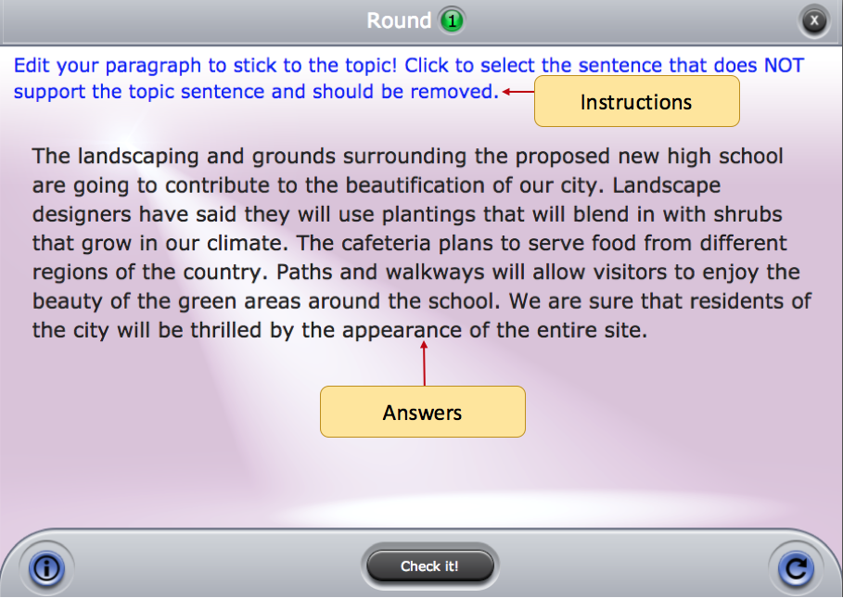

Instructions: (Use if the instructions are the same for the entire game)

Round #

**Instructions:** (Use if the instructions are round specific)

**Prompt:** (Rarely used for this game, but is available and can be text or image)

**Correct feedback:** Feedback that will display when correct answers are selected

**General incorrect feedback:** (Feedback that will display if any incorrect answer is selected)

**Answer pool and correct answers:**  Type the answer values here. [Words or sentences surrounded by brackets—like this one—are selectable in the game.] [!An exclamation point at the beginning of the brackets indicate correct answers.] [Individual] [words] [or longer phrases] Can be selectable. Words/phrases that aren’t surrounded by brackets aren’t selectable.